5 steps to prepare for winter
- Prepare perennials
Many perennials can be cut back in the spring, but it can be better to prune some perennials in the fall to avoid spreading diseases, such as powdery mildew. This is especially common in bee balm, phlox, and hosta’s.

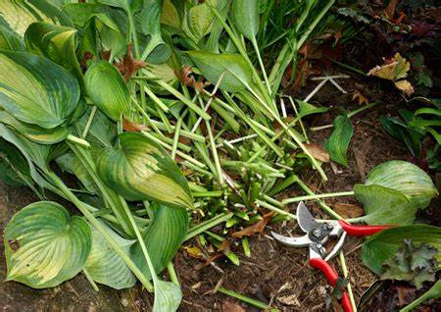
- Prepare trees
Tree wrap will help to stop winter injuries caused by sudden thawing. The combination of warm, sunny days and still-freezing nights in late winter can cause the thin bark of young trees to split. This is especially prevalent in trees with southern or southwestern exposure. Wrapping their trunks with tree wrap or otherwise shading them from the winter sun can stop bark injury.
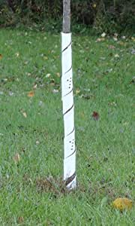

- Manage your compost
You’ll want to make sure you turn your compost pile or the contents of your compost bin one more time before hard frost. This introduces oxygen and speeds decomposition.

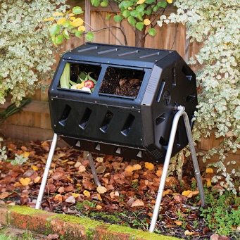

- Feed your lawn
The most influential application of the year occurs in the fall. If you haven’t done it, it is not too late. Apply a lawn fertilizer in autumn. Come spring your lawn will thank you by greening up quickly with much greater resistance to snow mold and brown-out.
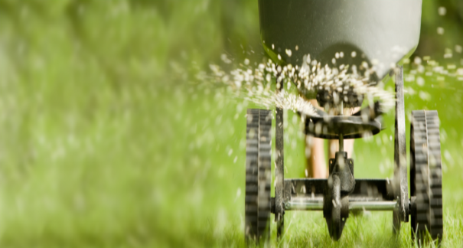

- Add in leaves
Rake the last of the fallen leaves off your lawn and into your garden. Run over the leaves with your lawnmower before raking them onto the surface of the gardens. Worms will pull the leaves down into the soil come spring, nourishing it.

